**DS PRACTICAL NO. :- 03**

***ARRAY SEARCHING AND SORTING***

**AIM:- [A]: Create an array of size n and write a program to sort a given array by selection sort and bubble sort.**

**PROGRAM:**

**(SELECTION SORT )**

**//selection sorting**

**#include<iostream>**

**using namespace std;**

**int main()**

**{**

**int a[5]={20,30,60,40,10};**

**int b;**

**for(int i=0; i<5;i++){**

**for(int j=0; j<4;j++){**

**if(a[j]>a[i]){**

**b=a[i];**

**a[i]=a[j];**

**a[j]=b;**

**}**

**}**

**}**

**cout<<"sorted array";**

**for(int i=0; i<5;i++){**

**cout<<a[i]<<" ";**

**}**

**return 0;**

**}**

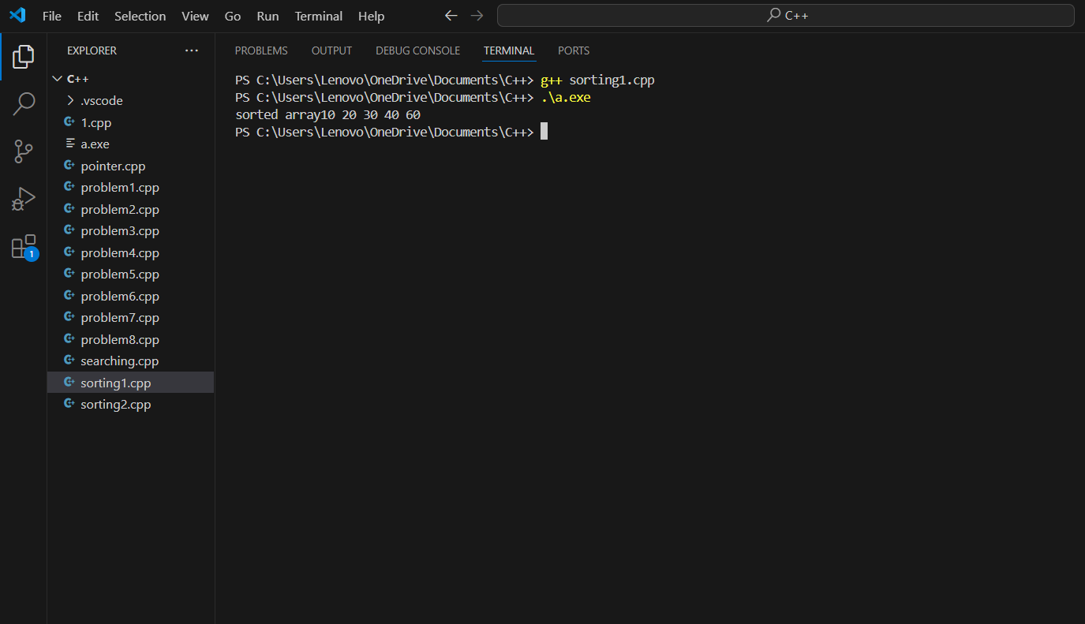

**(BUBBLE SORT)**

**//bubble sorting**

**#include<iostream>**

**using namespace std;**

**int main()**

**{**

**int a[5]={2,3,6,4,1};**

**int b;**

**for(int i=0;i<5;i++){**

**for(int j=0;j<4;j++){**

**if(a[j]>a[j+1]){**

**b=a[j];**

**a[j]=a[j+1];**

**a[j+1]=b;**

**}**

**}**

**}**

**cout<<"sorted array";**

**for(int i=0; i<5;i++){**

**cout<<a[i]<<" ";**

**}**

**return 0;**

**}**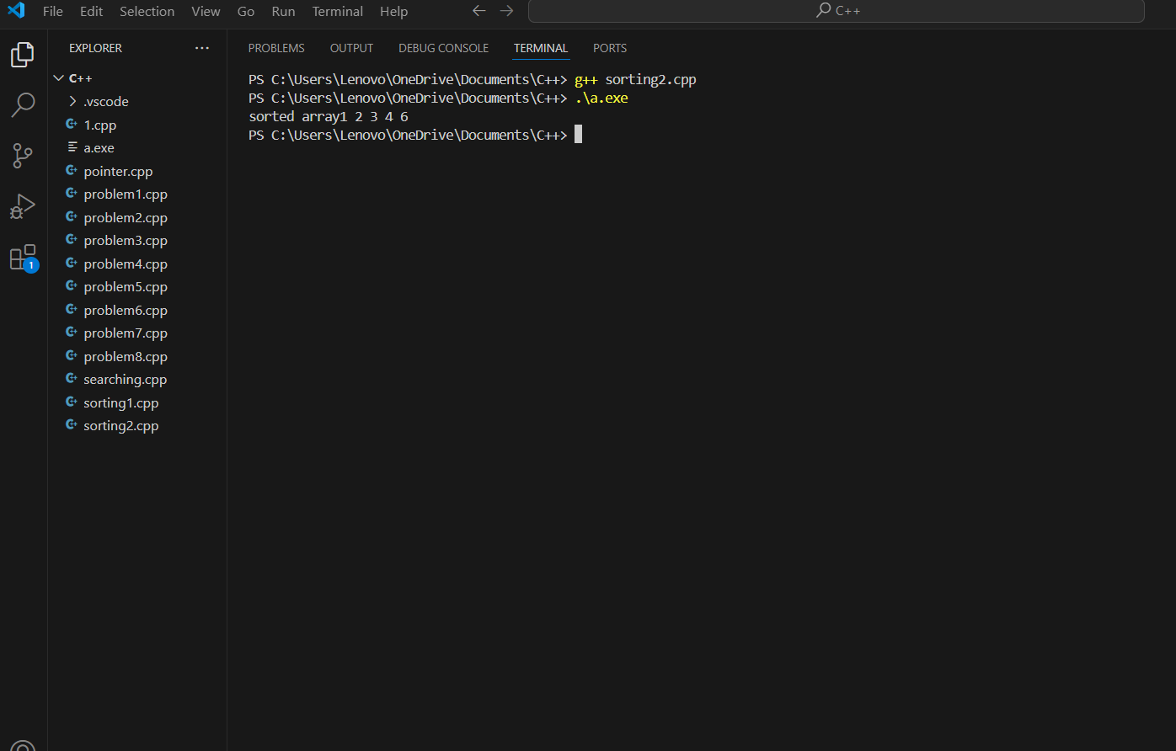

**[B]: Write a program to search any integer in your array using binary search concept.**

**#include <iostream>**

**using namespace std;**

**int main() {**

**int arr[] = {2, 3, 4, 10, 40};**

**int size = sizeof(arr) / sizeof(arr[0]);**

**int target;**

**cout<<"target element:";**

**cin>>target;**

**int low = 0;**

**int high = size - 1;**

**int result = -1;**

**while (low <= high) {**

**int mid = low + (high - low) / 2;**

**if (arr[mid] == target) {**

**result = mid;**

**break;**

**} else if (arr[mid] < target) {**

**low = mid + 1;**

**} else {**

**high = mid - 1;**

**}**

**}**

**if (result != -1) {**

**cout << "Element found at index " << result << endl;**

**} else {**

**cout << "Element not found" << endl;**

**}**

**return 0;**

**}**

